CSC2042S 2026 - Assignment 2 Logistic Regression News Topic Classification Report

1. Object- Oriented Design
The classifier is implemented as a MultinomialLogisticRegression class that comes from torch.nn.Module. The model has 1 learnable component: an nn.Linear(n_features, n_classes) layer. This layer takes the feature vector of each document and produces one logit for each class.
The model uses three separate methods for the different stages of prediction. The forward method returns the raw logits. These are used directly by nn.CrossEntropyLoss during training, which applies log-softmax internally to improve numerical stability. The compute_probabilities method applies an explicit softmax to the output of forward, producing a valid probability distribution for each example. Finally, predict returns the class index with the highest probability.Keeping these steps separate makes the different stages of softmax regression clearer: the model first produces linear scores, then normalises them into probabilities, and finally makes a class decision. It also reflects how the model is used differently during training and inference. During training, raw logits are used, while probabilities and hard predictions are used during inference.

2. Data Processing & Feature Extraction
For each article, the headline and article text were combined into a single piece of text. The same preprocessing and tokenisation methods were then applied to all three languages. This included converting text to lowercase, removing URLs and replacing sequences of digits with a shared <num> token.A single generic word-level regular expression tokenizer was used for all languages. This was important because there are no readily available stemmers or stopword lists for isiXhosa and chiShona. Using more linguistically specialised preprocessing for English would have given English an advantage and could have made the comparison between languages less fair.Two types of feature representations were created: Bag-of-Words (BoW) and TF-IDF. Both used unigrams and bigrams, with min_df = 2 and max_df = 0.95. The feature representations were fitted using only the training split to avoid information from the test data influencing the model.The resulting vocabulary sizes were 176,037 for English, based on 3,309 training articles, 34,012 for isiXhosa, based on 1,032 training articles, and 44,893 for chiShona, based on 1,288 training articles.

3. Training and Hyperparameter Tuning Process

The model was trained using mini-batch SGD and cross-entropy loss, with the training data reshuffled each epoch. Early stopping monitored development accuracy with a patience of 5 and a maximum of 50 epochs. The weights from the best-performing epoch were restored rather than using the final epoch, as development accuracy tended to fluctuate after reaching its peak. An initial fixed-hyperparameter comparison (Table 1) showed that BoW performed better than TF-IDF for all three languages. However, a diagnostic run showed that this was partly due to the learning rate. TF-IDF features are L2-normalised and therefore much smaller than raw BoW counts, so a learning rate of 0.1 was too small for TF-IDF. Increasing it to 1.0 resulted in better updates, so learning rate was tuned separately for each feature type.
Table 1. BoW vs TF-IDF with fixed hyperparameters
Language | BoW (dev) | TF-IDF (dev)
English | 86.86% | 86.44%
isiXhosa | 88.44% | 80.95%
chiShona | 90.27% | 85.41%
A grid search was then performed for each language and feature type using learning rate{0.1, 1.0}, batch size {32, 128}, maximum vocabulary size {10000, unlimited} and minimum document frequency {0, 3, 5,10} Since scikit-learn does not allow min_df= 0, it was implemented as min_df = 1. This gave 32 configurations per language and feature pair. The best configuration was selected using development accuracy and then evaluated once on the test set.
Table 2. Best configuration per language and feature type
Language | Feature | min_df | Max feat. | LR | Batch | Dev | Test
English | BoW | 5 | 10,000 | 1.0 | 32 | 87.92% | 88.50%
English | TF-IDF | 3 | 10,000 | 1.0 | 32 | 88.35% | 89.87%
isiXhosa | BoW | 3 | 10,000 | 1.0 | 32 | 92.52% | 87.54%
isiXhosa | TF-IDF | none | unlimited | 1.0 | 32 | 86.39% | 85.86%
chiShona | BoW | 10 | unlimited | 1.0 | 128 | 91.35% | 89.16%
chiShona | TF-IDF | 5 | 10,000 | 1.0 | 32 | 90.27% | 94.58%
A learning rate of 1.0 was the best setting for every language and feature type. Batch size 32 was generally preferred, likely because smaller batches provide more gradient updates before the early-stopping patience counter is reached. Vocabulary size & minimum document frequency had no consistent best setting across languages. After tuning, TF-IDF performed better than BoW for English and chiShona, reversing the result from Table 1. This showed that comparing feature types using a single fixed set of hyperparameters can be misleading.
Figure 1 shows the training and development loss curves for the best English and isiXhosa configurations. English BoW shows a sharp instability spike around epoch 6, despite the overall downward trend. This is likely due to a large, noisy gradient update from the raw-count features. The TF-IDF curves are smoother, which is consistent with its normalised feature values producing more stable updates once the learning rate is properly matched.
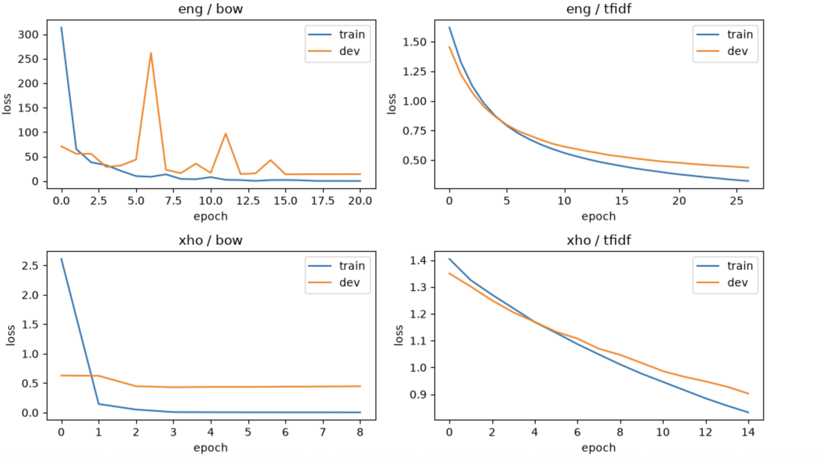

4. Weight Analysis (English)
The weight matrix from the best English model was examined. Since the model is linear, each weight shows how much a feature contributes to a class's score. Most of the highest-weighted features made sense for their classes. For example, health included hospital, patients and covid, while sports included sport, games and team. However, the top political features included sunak (3.37) and rishi sunak (2.44). These refer to a specific UK Prime Minister who was in office when the data was collected rather than a general political concept. This suggests that the model partly learned features linked to the time period of the dataset rather tha more general topic information. This could reduce its accuracy on political news from a different time period, even when the news covers the same general topic.

5. IsiXhosa Class Imbalance
The isiXhosa training data is imbalanced, with 50 business, 70 health, 215 politics, 347 sports and 350 entertainmentarticles. The best isiXhosa BoW configuration from Section 3 was kept unchanged while only the sampling strategy was varied. Results were averaged across 3 fixed seeds to reduce training-run variation. A pilot run showed that the same configuration could vary by several accuracy points between runs.
Table 3. IsiXhosa sampling results
Strategy | Setting | Mean dev acc. | Test acc.
No sampling | - | 88.66% | 90.24%
Upsampling | α = 1.0 | 88.21% | 87.21%
Downsampling | rate = 0.5 | 89.34% | 87.54%
Neither resamplin method improved test accuracy compared with the unsampled baseline. Although moderate downsampling produced the highest mean development accuracy, it did not perform as well on the test set. Aggressive downsampling, where all classes are reduced to the smallest class size of 50 examples, was clearly harmful. This suggests that removing majority-class training data can have a larger negative effect than the original class imbalance.
Figure 2 shows the confusion matrix for the no-sampling baseline. Business was mainly confused with politics, with 7 of 15 business articles being classified as politics. It was never confused with entertainment or sports. This suggests that the model's difficulty with the smaller business class is mainly related to the overlap between business and politics, particularly because both can involve government and economic decisions.
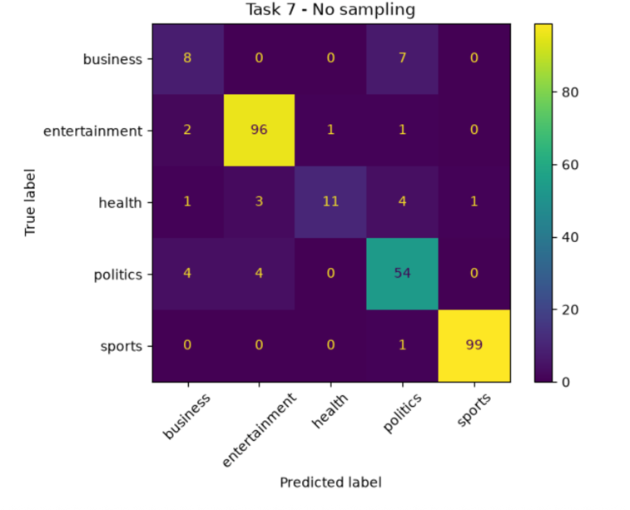

6. Bilingual Training

Before running the experiments, my prediction was that combining isiXhosa with chiShona would help isiXhosa more than combining isiXhosa with English. The reasoning was that chiShona is a similarly sized and linguistically related Bantu language, while English has a much larger vocabulary that could take up more space in a shared, size-limited feature space. For both bilingual experiments, the isiXhosa BoW settings from Section 3 were kept the same and only the maximum vocabulary size was changed.

Table 4. Bilingual isiXhosa results
Pairing | Best max_features | Dev acc. (isiXhosa) | Test acc. (isiXhosa)
isiXhosa + chiShona | 20,000 | 89.80% | 89.90%
isiXhosa + English | Unlimited (120,798) | 87.98% | 89.23%
My prediction was correct in direction, but the difference was small. isiXhosa + chiShona achieved 89.90% test accuracy compared with 89.23% for isiXhosa + English, a difference of only 0.67 percentage points. Vocabulary size also behaved differently across the two pairings. For chiShona, isiXhosa accuracy increased from 87.30% to 89.80% when the vocabulary increased from 2,000 to 20,000 features, before falling slightly with the full 41,508-feature vocabulary. For English, accuracy continued to improve as the vocabulary increased, reaching its best result with the full unlimited vocabulary of 120,798 features. This was the opposite of the expected crowding-out effect. Neither bilingual model performed better than the best monolingual isiXhosa result.

7. Combined isiXhosa Test Results
Table 5 shows that the best overall result was achieved by isiXhosa + chiShona bilingual training, with 89.90% accuracy. Bilingual training performed better than all of the monolingual sampling strategies tested, while neither upsampling nor downsampling improved on the standard monolingual baseline. However, the exact results should be interpreted carefully. A re-seeded run of the same no-sampling configuration achieved 90.24% test accuracy compared with 87.54% in Task 5. This shows that the small isiXhosa test set of 297 examples can produce several percentage points of variation between runs. Therefore, differences of only one or two percentage points between results should not be over-interpreted.
Source Configuration Test accuracy
Task 5 (monolingual, no sampling) BoW, min_df=3, max_feat=10,000 87.54%
Task 7 - Upsampling alpha = 1.0 87.21%
Task 7 - Downsampling rate = 0.5 8 7.54%
Task 8 - isiXhosa + chiShona max_feat = 20,000 89.90%
Task 8 - isiXhosa + English max_feat = unlimited 89.23%

8. Conclusion and Limitations
Across the experiments, learning rate was the most influential hyperparameter. The best learning rate depended on the feature scale, particularly whether BoW or TF-IDF was used, rather than being the same for every model.The experiments also showed that both feature comparisons and class-imbalance methods can be affected by factors that are easy to miss in a single run. These included using an unsuitable learning rate for TF-IDF and variation between training runs. This highlights the importance of controlled comparisons using fixed seeds. For isiXhosa, combining its training data with a second language was more effective than directly addressing the class imbalance through sampling. However, the improvement over the standard monolingual baseline was still modest, at under 3 percentage points, and statistical significance was not tested because the isiXhosa test set was small.
References + AI Declaration
I used ChatGPT andGoogle Gemini in this assignment for debugging, code review (help with which methods/functions I could consider researching/looking into and sites I should visit to learn more), and feedback on my written analysis, proofreading my comments+docstrings on functions/methods. I would say what influenced most towards my final submission was the debugging as it meant I could continue without problems for the rest of the tasks.
Sites visited
Pedregosa, F., et al. Scikit-learn: TfidfVectorizer. Scikit-learn documentation. https://scikit-learn.org/stable/modules/generated/sklearn.feature_extraction.text.TfidfVectorizer.html - Last accessed September 20, 2026.
Pedregosa, F., et al. Scikit-learn: CountVectorizer. Scikit-learn documentation. https://scikit-learn.org/stable/modules/generated/sklearn.feature_extraction.text.CountVectorizer.html - Last accessed September 21, 2026.
Pedregosa, F., et al. Scikit-learn: LabelEncoder. Scikit-learn documentation. https://scikit-learn.org/stable/modules/generated/sklearn.preprocessing.LabelEncoder.html - Last accessed September 20, 2026.
Pedregosa, F., et al. Scikit-learn: Metrics and scoring (accuracy_score, precision_score, recall_score, f1_score, classification_report, ConfusionMatrixDisplay). Scikit-learn documentation. https://scikit-learn.org/stable/modules/model_evaluation.html - Last accessed September 21, 2026.
PyTorch. torch.nn.functional.softmax. PyTorch documentation. https://pytorch.org/docs/stable/generated/torch.nn.functional.softmax.html - Last accessed September 21, 2026.
PyTorch. torch.optim.SGD. PyTorch documentation. https://pytorch.org/docs/stable/generated/torch.optim.SGD.html - Last accessed September 20, 2026.
PyTorch. Autograd: Automatic Differentiation. PyTorch documentation. https://pytorch.org/docs/stable/autograd.html - Last accessed September 21, 2026.
PyTorch. torch.nn.Linear. PyTorch documentation. https://pytorch.org/docs/stable/generated/torch.nn.Linear.html- Last accessed September 20, 2026.
PyTorch. torch.utils.data.WeightedRandomSampler. PyTorch documentation. https://pytorch.org/docs/stable/data.html#torch.utils.data.WeightedRandomSampler - Last accessed September 21, 2026.
Scikit-learn developers. Plot multinomial and One-vs-Rest Logistic Regression. Scikit-learn documentation. https://scikit-learn.org/stable/auto_examples/linear_model/plot_logistic_multinomial.html - Last accessed September 21, 2026.
Brownlee, J. Random Oversampling and Undersampling for Imbalanced Classification. Machine Learning Mastery. https://machinelearningmastery.com/random-oversampling-and-undersampling-for-imbalanced-classification/ - Last accessed September 20, 2026.

